ARP

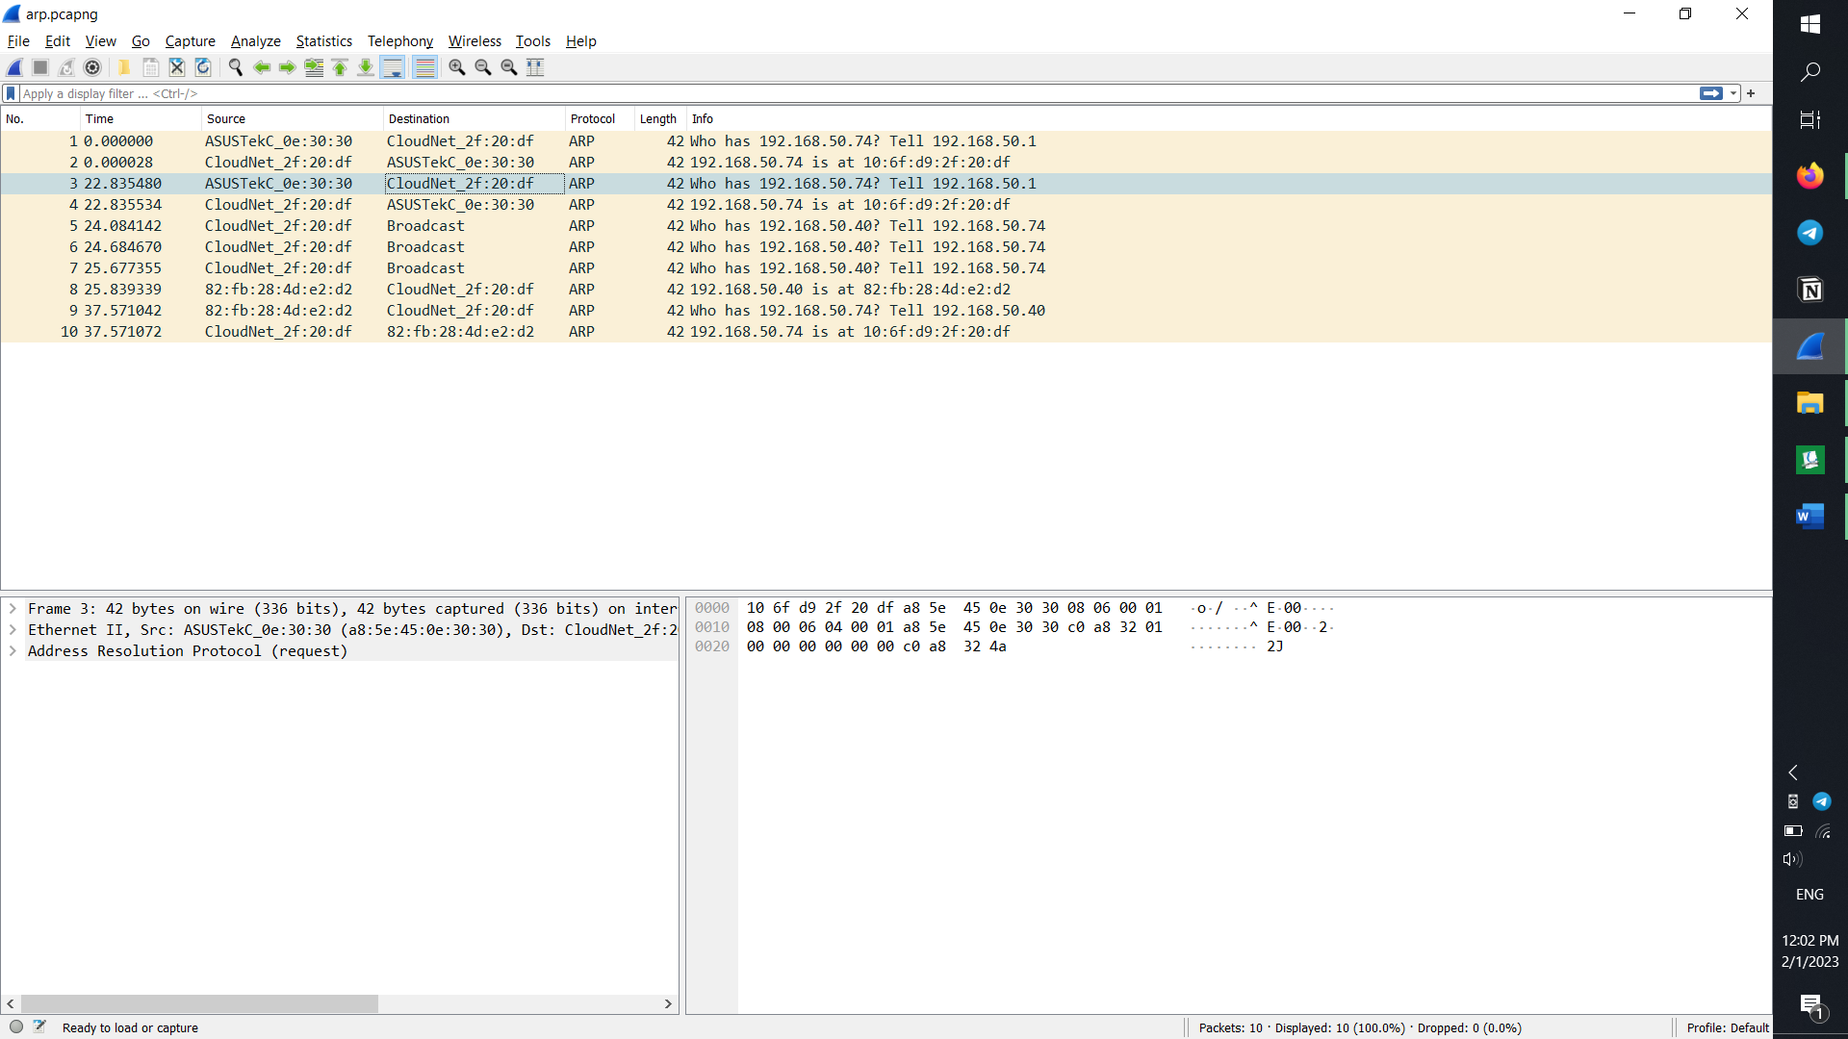 (request)

Sender hardware address: a8 5e 45 0e 30 30  
Sender prorocol address: c0 a8 32 01   
Target hardware address: 00 00 00 00 00 00  
Target prorocol address: c0 a8 32 4a  
Opcode: 00 01  
Type: 08 00 (Ipv4)

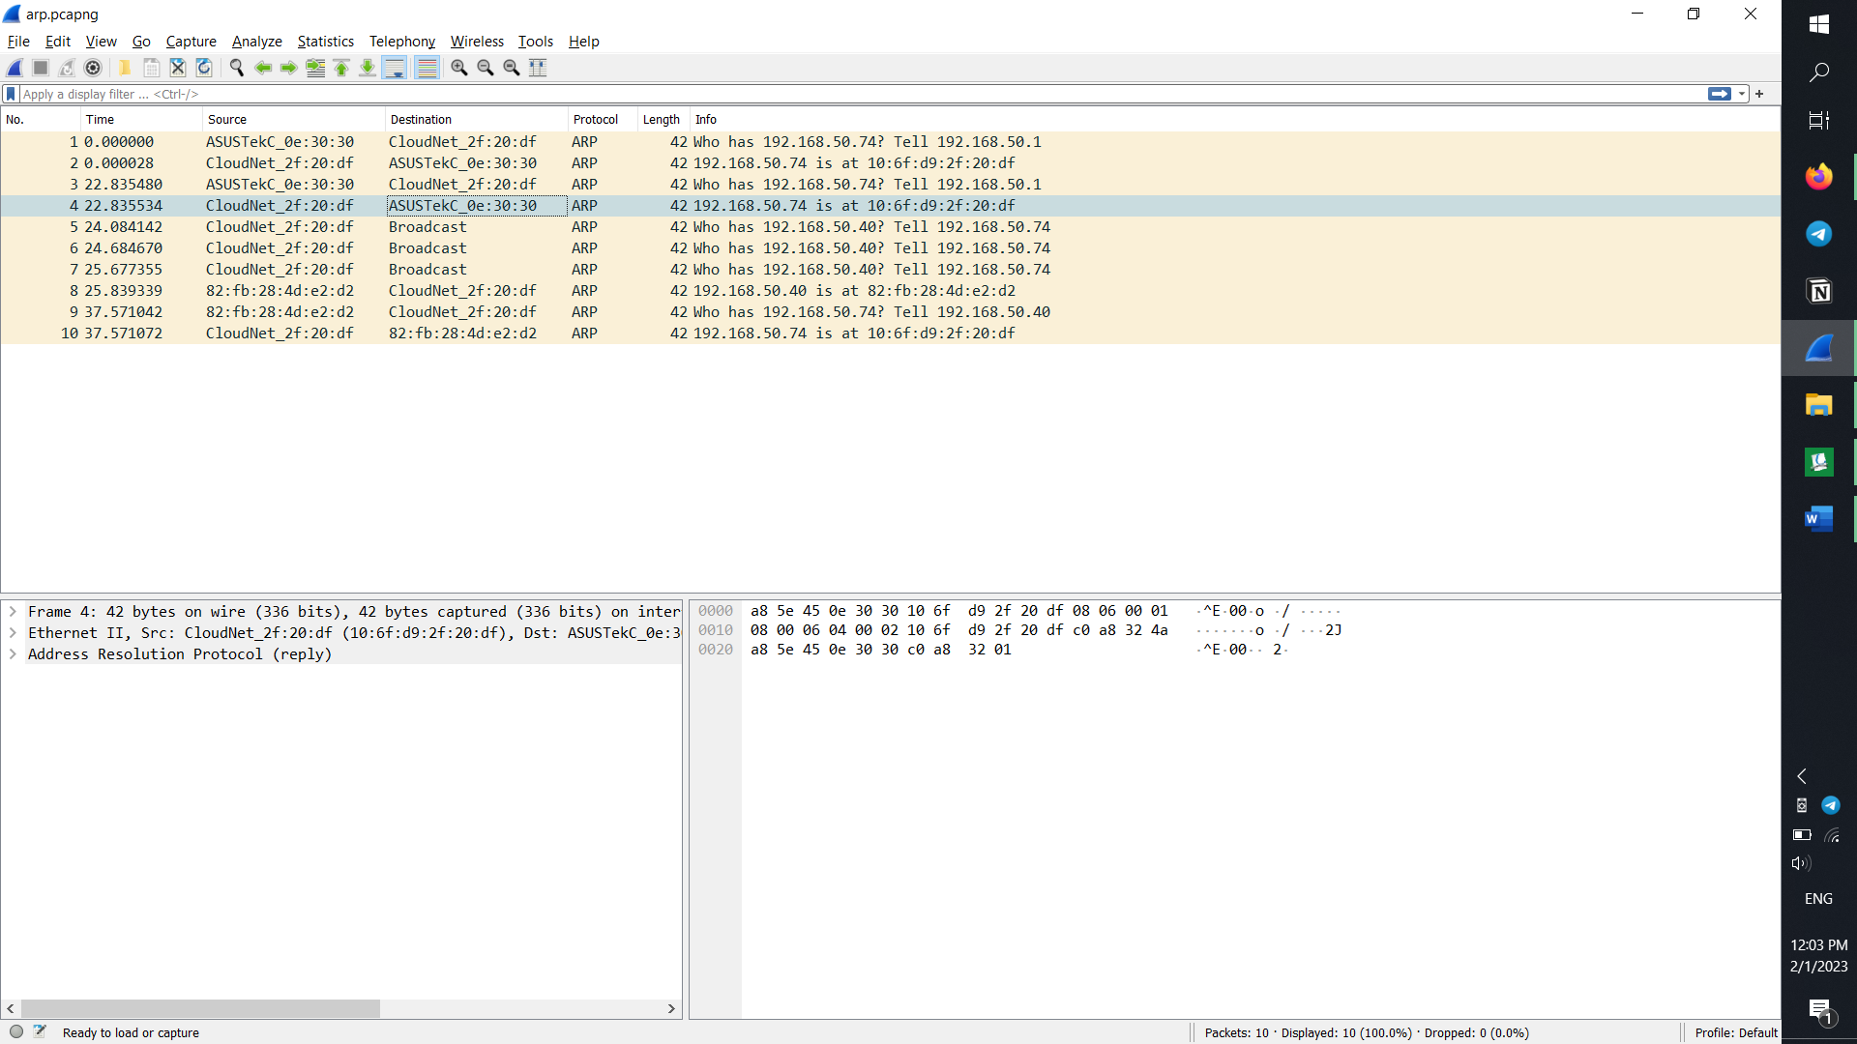 (answer)

Sender hardware address: 10 6f d9 2f 20 df  
Sender prorocol address: c0 a8 32 4a  
Target hardware address: a8 5e 45 0e 30 30  
Target prorocol address: c0 a8 32 01  
Opcode: 00 02  
Type: 08 00 (Ipv4)

DNS 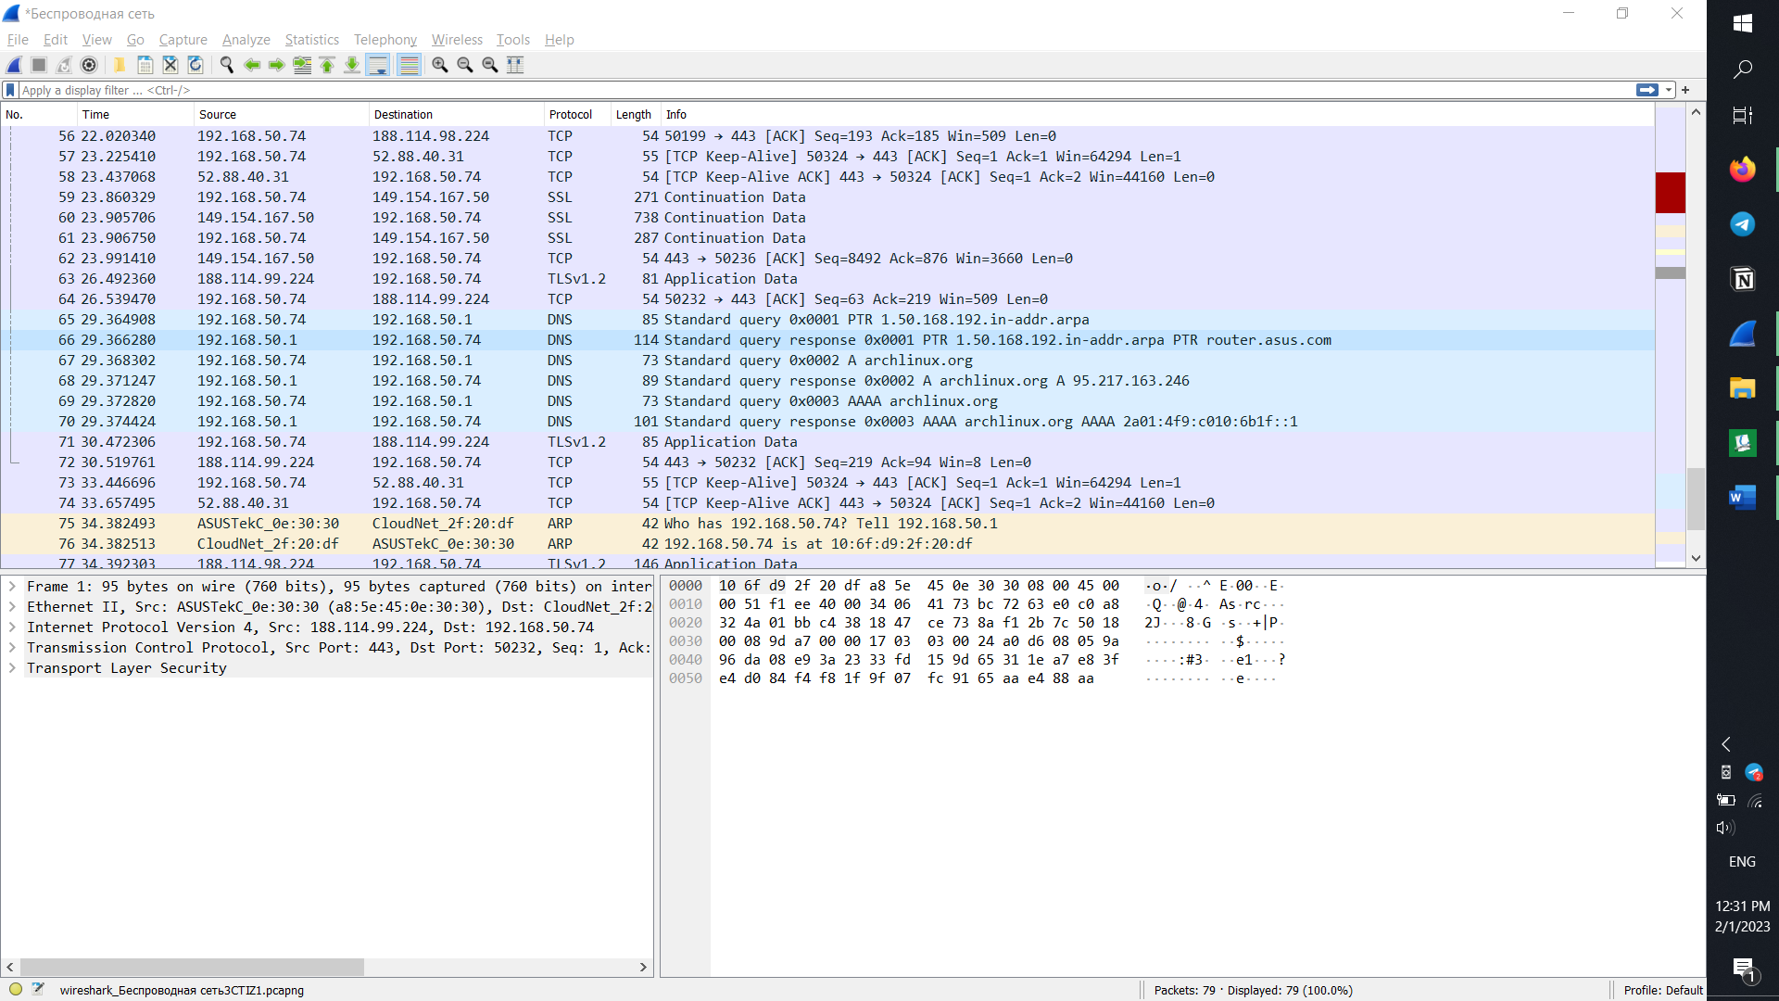

Работает поверх tcp/udp

(запрос)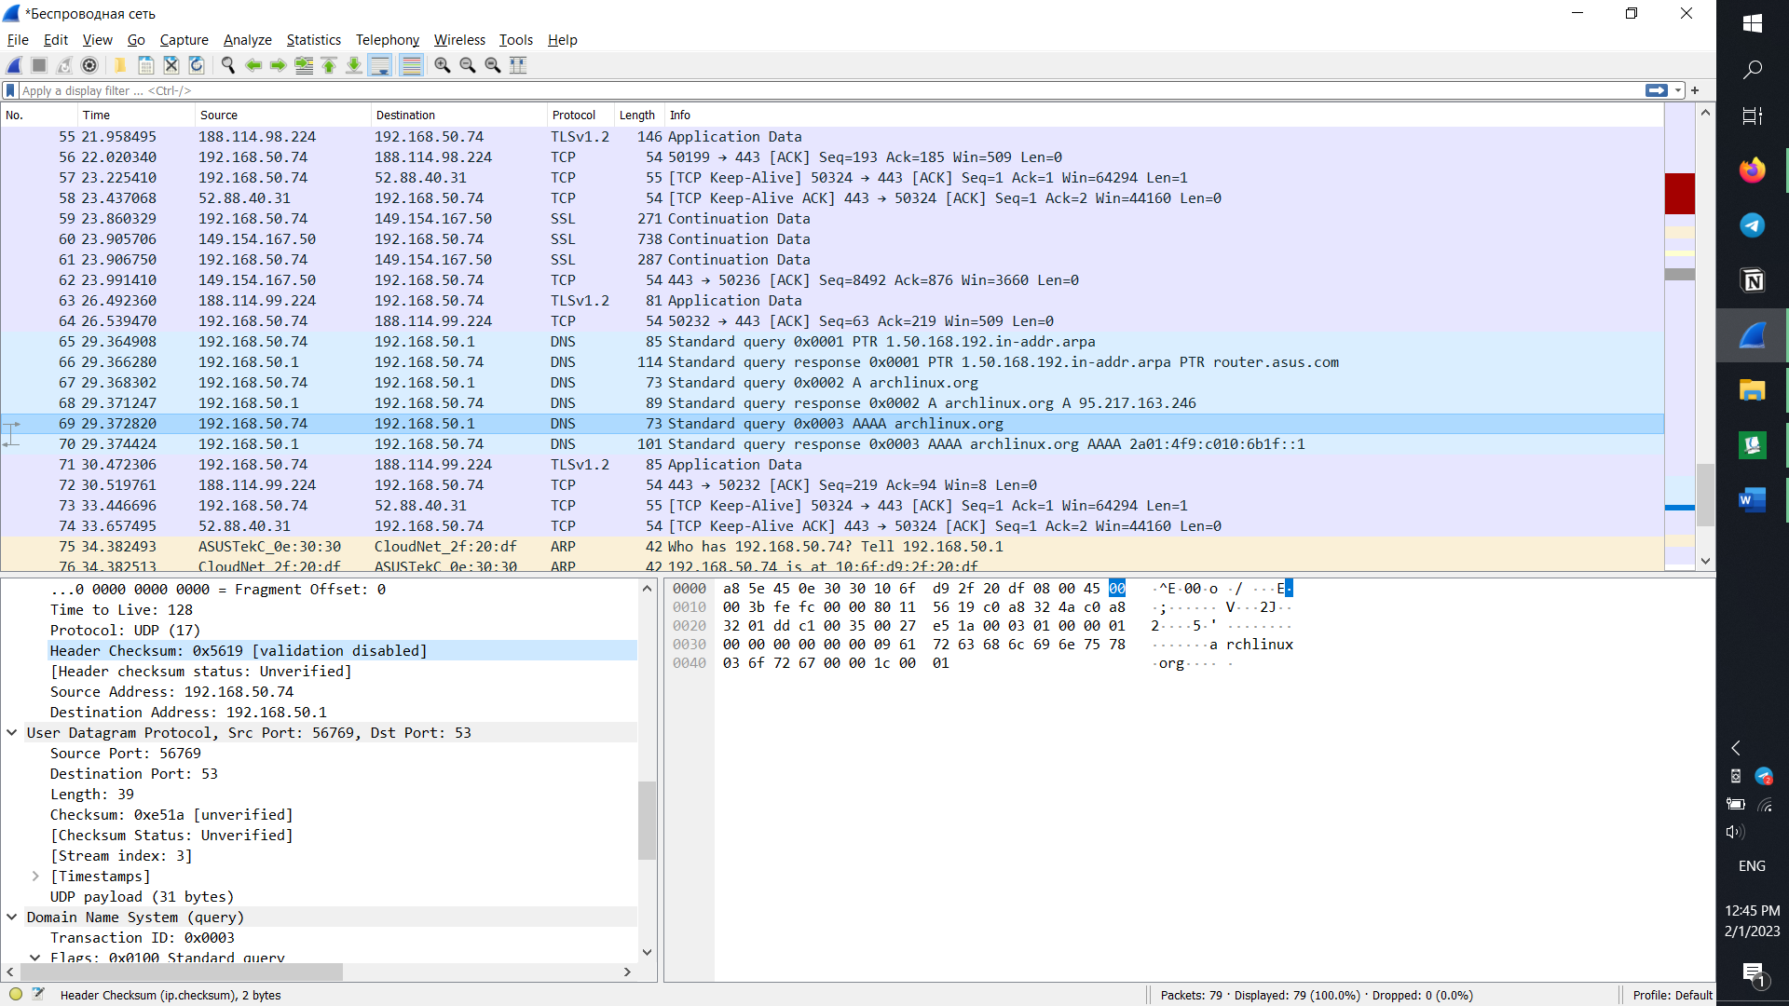

Отправлен на с0 a8 32 01 (адрес роутера)  
тип – 08 00 (Ipv4)

(ответ) 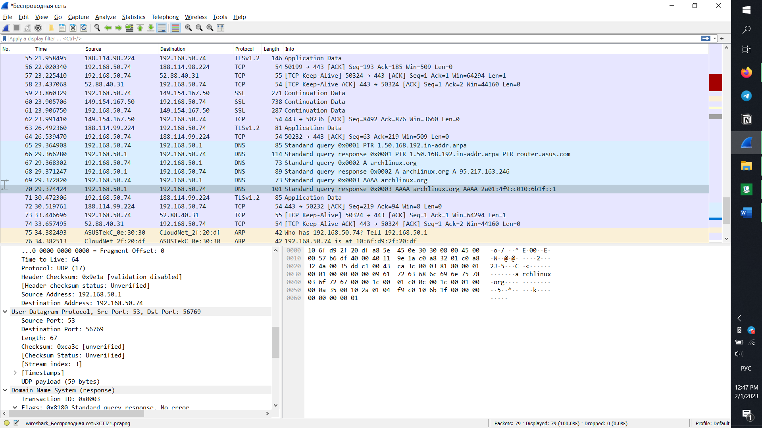

В поле ответа: 